MCARTHUR NURSeRY SCHOOL  JOIN US FOR AN OPEN DAY  6 December 2023  DROP IN - 9.30 – 11.30  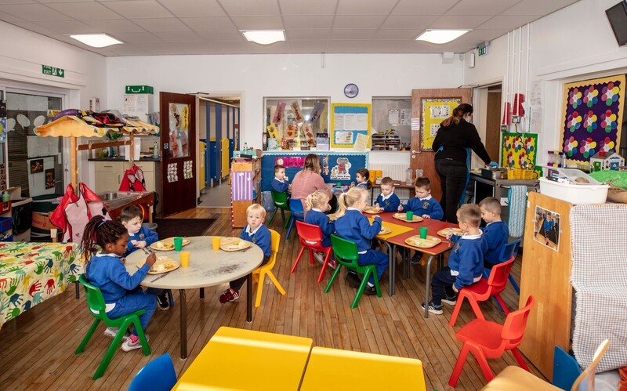  You are invited to drop in and meet Teachers and Staff  SEE US IN ACTION  Our experienced staff work hard to provide a well balanced approach to preschool development using the indoor and outdoor environment within the school curriculum.  Play  Nurture  Grow  We are looking forward to meeting you.  School Hours 8.30am – 1.00pm  After School Provision | Prospective Parents  Come and see what we can offer your child  Well-resourced classrooms  A large outdoor play area for shared play  Friendly and experienced staff  Safe and supportive fun filled learning experience  MCARTHUR NURSERY SCHOOL  SUSAN STREET  BELFAST BT5  02890451965  www.mcarthurnurseryschool@hotmail.com  www.mcarthurnurseryschool.co.uk  Facebook –MCARTHUR NURSERY SCHOOL

